The concept of CPU scheduling allows a set of processes to share the CPU and increasing CPU utilization. This set of processes needs to exist in memory. Memory management is the functionality of an operating system which manages memory and keeps record of every memory location either it is allocated to several process or it is free. It checks how much memory is to be allocated to processes. It decides which process will get memory at what time. It updates the status of memory.

- Background
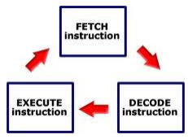
Memory consists of a large array of bytes or words, each with its own address. The CPU fetches instructions from memory according to the value of the program counter. A typical instruction execution cycle first fetches an instruction from memory. The instruction is decoded and may operands to be fetched from memory. After the instruction has been executed on the operands, results may be stored back in memory. The memory unit sees only a stream of memory addresses.

- Basic Hardware
- Each process should have a separate memory space. Memory management provides protection by using two registers, a base register and a limit register.
- The base register holds the smallest legal physical memory address.
- The limit register specifies the size of the range.
Example, if the base register holds 300000 and the limit register is 120000, then the program can legally access all addresses from 300000 through 411999.
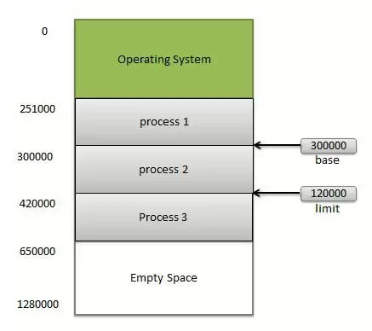
Figure: A base and a limit register define a logical address space.
- Protection of memory space is authority by having the CPU hardware compare every address generated in user mode compare with the registers.
- A program executing in user mode to access OS memory if it access other memory address then OS trap this process address which treat as a fatal error.
- This protection prevents a user program from modifying the code or data structures of OS or other user’s process.
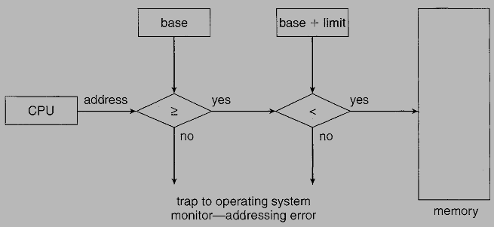
Figure: Hardware address protection with base and limit registers.
The base and limit registers can be loaded only by the OS which uses a special privileged instruction.
- Address Binding
- A program place on a disk a binary executable file. To executing, the program must be bring into memory and placed within a process. The processes on the disk that are waiting to bring into memory for execution.
- Process selects from input queue and load into memory. Process is executed; it access instructions and data from memory. Then process terminates and its memory space is available.
- Addresses may be represented in different ways during these steps.
- Addresses in the source program are symbolic. A compiler will bind these symbolic addresses to relocatable addresses. The linkage editor or loader will in turn bind the relocatable addresses to absolute addresses. Each binding is a mapping from one address space to another.
The binding of instructions and data to memory addresses can be done at:
- Compile time – If you know at compile time, where the process will exist in memory, then absolute code can be generated.
- Load time – If it is not known at compile time where the process will exist in memory, then the compiler must generate relocatable code. Final binding is delayed until load time.
- Execution time – If the process can be moved during its execution from one memory segment to another, then binding must be delayed until run time.

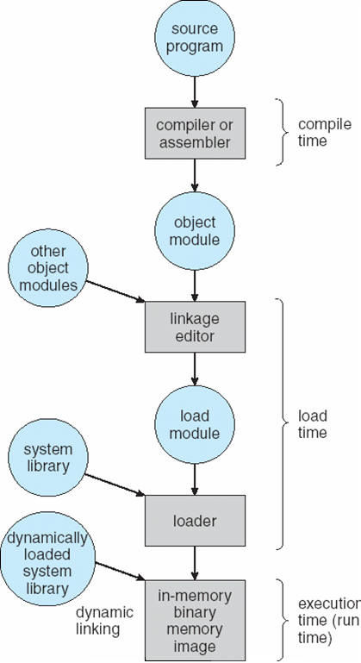

Figure: Multistep processing of a user program.

- Logical versus Physical Address Space
- An address generated by the CPU is called as Logical Address and also called as Virtual Address
- Where address really available on memory unit is called as Physical Address.
- Logical and physical addresses are the same in compile-time and load-time address-binding schemes.
- Logical and physical addresses differ in execution-time address-binding scheme.
- The set of all logical addresses generated by a program is referred to as a logical address space.
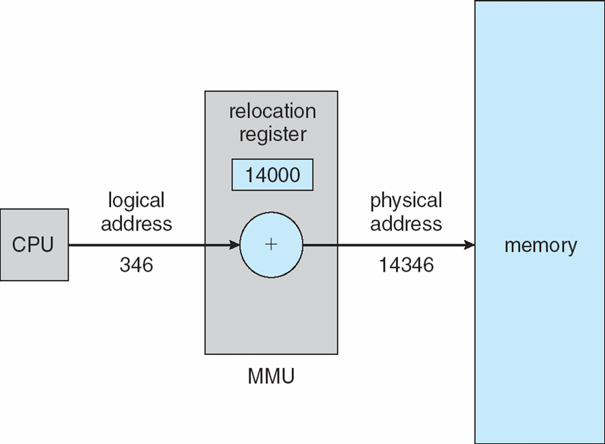
- The set of all physical addresses corresponding to these logical addresses is referred to as a physical address space.

Figure: Dynamic relocation using a relocation register.
- The run time mapping from virtual to physical addresses is done by a hardware device called the memory management unit (MMU). MMU uses following mechanism to convert virtual address to physical address.
- Every address generated by a user process added to base register (relocation register) at the time it is sent to memory. For example, if the base register value is 14000, then the user to use address location 346 will be dynamically reallocated to location 14346.
- The user program deals with virtual addresses; it never sees the real physical addresses.

- Dynamic Loading
- The entire program and its all data of a process must be in physical memory for execution. The size of a process is larger than size of physical memory.
- To use dynamic loading for memory space utilization. With dynamic loading, a routine is not loaded in memory without calling. All routines are kept on disk in a relocatable load format. The main program is loaded into memory and is executed.
- When a running routine needs to call another routine, the calling routine first checks to their other routine has been loaded or not. If no routine then relocatable linking loader is called to load the needed routine into memory and to update the program’s address tables. Then control is passed to the newly loaded routine.
- The advantage of dynamic loading is that an unused routine is not loaded in memory. This method is Useful when large amounts of code are needed to handle rarely occurring cases such as Error routines. Dynamic loading does not require special support from the OS.

- Overlays
- When entire program and its related data are loaded in physical memory for execution.
But what if process is larger than the amount of memory allocated to it.
- Overcome this problem by using a technique called as Overlays. Overlays can also be implemented by users without OS support. The entire program or application is divided into instructions and data sets such that when one instruction set is needed it is loaded in memory and after its execution is over, the space is released.
- When requirement for other instruction arises it is loaded into space that was released previously by the instructions that are no longer needed. Such instructions can be called as overlays, which are loaded and unloaded by the program.
- For example, suppose total available memory is 140K. Consider a program with four subroutines named as: Read ( ), Function1 ( ), Function2 ( ) and Display ( ).First, Read is invoked that reads a set of data. Based on this data set values, conditionally either one of routine Function1 or Function2 is called. Then Display is called for output results. Here, Function1 and Function2 are mutually exclusive and are not required simultaneously in memory. The memory requirement can be shown as in figure. Without the overlay it requires 180 K of memory and with the overlay support memory requirement is 130K.
- Overlay manager/driver is responsible for loading and unloading on overlay segment as per requirement. But this scheme suffers from following limitations:
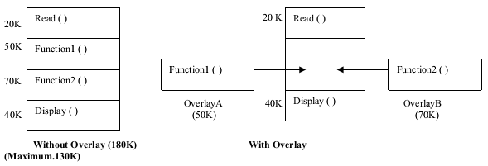
Figure: Example of overlay
• Require careful and time-consuming planning.
• Programmer is responsible for organizing overlay structure of program with the help of file structures etc. and also to ensure that piece of code is already loaded when it is called.
• Operating System provides the facility to load files into overlay region.

- Dynamic linking and shared libraries
Linking is the process of collecting and combining various modules of code and data into a executable file that can be loaded into memory and executed. Operating system can link system level libraries to a program. When it combines the libraries at load time, the linking is called static linking and when this linking is done at the time of execution, it is called as dynamic linking.
In static linking, libraries linked at compile time, so program code size becomes bigger whereas in dynamic linking libraries linked at execution time so program code size remains smaller.

- Swapping
- A process needs to be in memory during execution. A process can be swapped out from main memory in certain situations to a backing store and then swapped in into memory to continue remaining execution.
- One such situation could be the expiry of a time slice (Time Quantum) if the round-robin CPU scheduling algorithm is used. When time slice expired the running process is swapped out from memory and another process is swapped into the memory space.
- Every time a time slice expires, a process is swapped out and another is swapped in. The memory manager that does the swapping is fast. The duration of a time slice is carefully choose sufficiently large when compared to the time for swapping.
- Second situation when priority based CPU scheduling is used. The entered process is high priority process that replaces running process that is a lower priority process swapped out and high priority process swap in. The swapping referred as roll out / roll in.
- A process is swapped out & swapped in from memory the memory location same or different memory location. If binding is done at load time then swap in has to be at the same location. But if binding is done at execution time then swap in can be into a different memory space since the mapping to physical addresses is completed during execution time.
- A backing store is required for swapping. When the CPU scheduler picks a process for execution, the dispatcher checks to see if the picked process is already in memory then it is executed otherwise the process has to be loaded into main memory.
- If space is available in memory then the process is load and execute. If no space in memory the dispatcher swaps out a process from memory and swap in the preferred process. A process to be swapped out must be idle. Pending I/O arise Problems.
- Consider the following example: Process P1 is waiting for an I/O. I/O is delayed because the device is busy. If P1 is swapped out and P2 is swapped in, the I/O uses the memory that belongs to P2 memory area. There can be two solutions to the above problem:
- Never swap out a process that is waiting for an I/O
- Allow I/O operations to take place only in operating system buffers and not in user area buffers. These buffers can then be transferred into user area when the related process is swapped in.
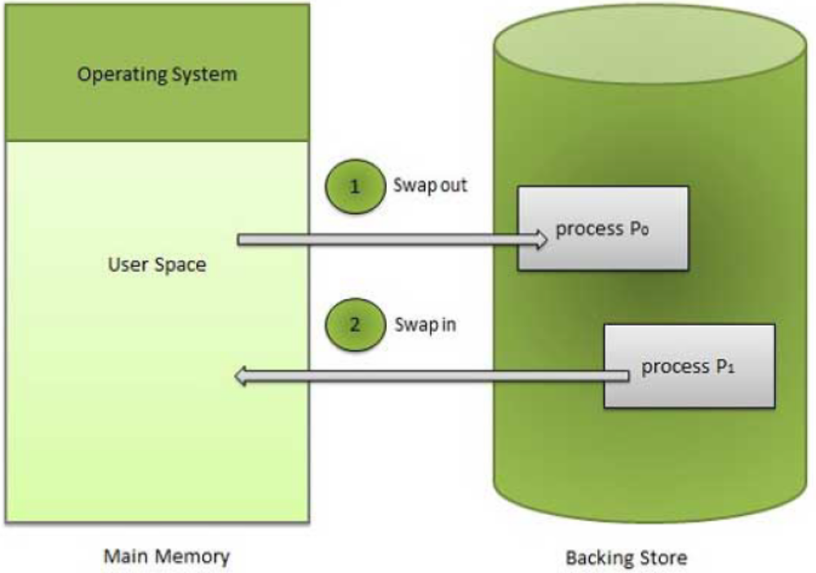
Figure: Swapping Process

- Contiguous Memory Allocation
The main memory must hold both the OS process and user processes. That is it divided into two partitions: one partition occupies by OS and second partition occupies by the user processes. OS can be placed either in low memory or high memory. Several user processes should reside in memory at the same time. In contiguous memory Allocation, each process is contained in a single contiguous memory.
0k
OS

User process

40k

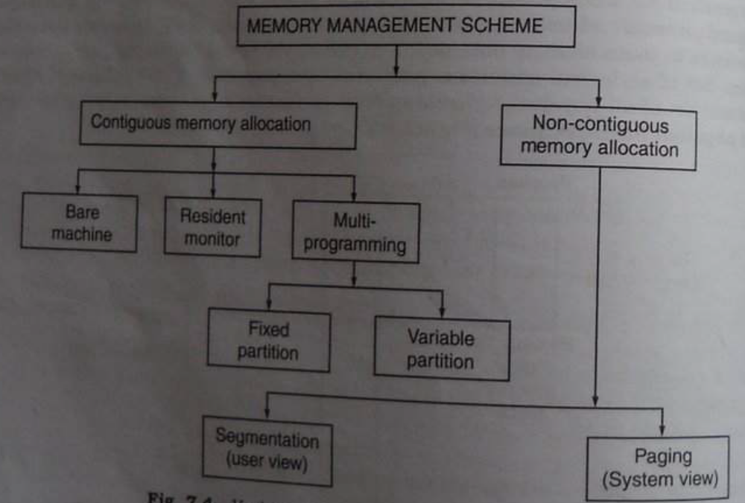

- Single Partition Allocation (Memory Mapping and Protection)
The operating system resides in the lower memory. User processes execute in the higher memory. There is always a possibility that user processes may try to access the lower memory either accidentally or purposely thereby causing loss of operating system code and data. This protection is usually provided by the use of a limit register and relocation register. The relocation register contains the smallest physical address that can be accessed. The limit register contains the range of logical addresses. Each logical address must be less than the content of the limit register. The MMU adds to the logical address the value in the relocation register to generate the corresponding address (Figure). Since an address generated by the CPU is checked against these two registers, both the operating system and other user programs and data are protected and are not accessible by the running process.
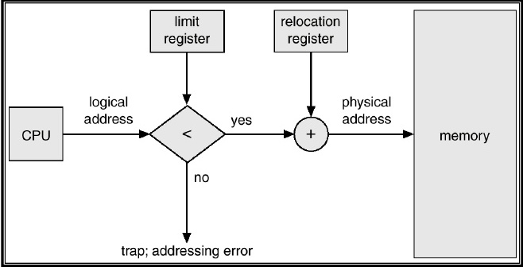
- Multiple Partition Allocation
Multiprogramming requires that there are many processes place in memory so that the CPU can switch between processes. If user area of memory divided into fixed number of partitions, each one to hold one user process. Thus the degree of multiprogramming is equal to the number of partitions. A process from the ready queue is loaded into one of the free partitions for execution. On termination of process the partition is free for another process to be loaded. The disadvantage is partitions size fixed when process size is smaller than available free partitions then process load and remaining partitions space is wasted is called as Internal Fragmentation.
0k
Page number
OS

P1 (80K)
20K empty
P2 (100K)

16K empty space

40k

Internal Fragmentation
140k

240k

256k
From this figure, there are two processes P1 use 80k size, P2 use 100k, P3 use 16 k size. But free space 20k is wasted that is a internal fragmentation because partition size 100k & process size 80k, remaining 20k cannot allocate to other process.
0k
Page number
OS

P1 (80K)
20K empty
P2 (100K)

16K empty space

40k

120k
140k

240k
External Fragmentation
256k
Suppose process P3 wants 30k size but empty space in memory is 16k & 20k. External fragmentation exists when there is enough total memory space to satisfy a request but the available spaces are not contiguous; storage is fragmented into a large number of small holes.
Another scheme is Variable sized partition to deal with the problem of determining the number and sizes of partitions to minimize internal and external fragmentation. If we use variable partitioning instead of fixed size, then partition sizes may vary dynamically.
In the variable partitioning method, we keep a table (linked list) indicating used/free areas in
memory. Initially, the whole memory is free and it is considered as one large block. When a
new process arrives, the OS searches for a block of free memory large enough for that
process. We keep the rest available (free) for the future processes. If a block becomes free,
then the OS tries to merge it with its neighbors if they are also free.
There are three algorithms for searching the list of free blocks for a specific amount of memory.
- First Fit: Allocate the first free block that is large enough for the new process.
- Best Fit: Allocate the smallest block among those that are large enough for the new process.
- Worst Fit: Allocate the largest block among those that are large enough for the new process.

Example
Consider the following memory map and assume a new process P4 comes with a memory
requirement of 3 KB. Locate this process.
a. First fit algorithm allocates from the 10 KB block.
b. Best fit algorithm allocates from the 4 KB block.
c. Worst fit algorithm allocates from the 16 KB block.
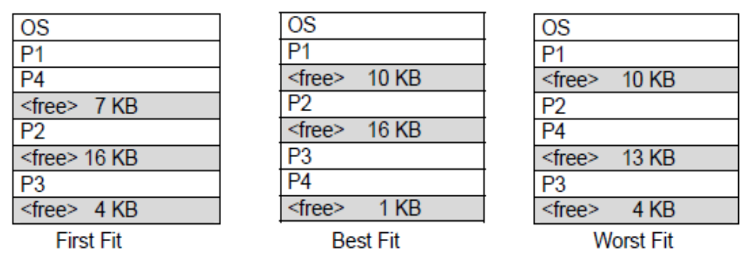
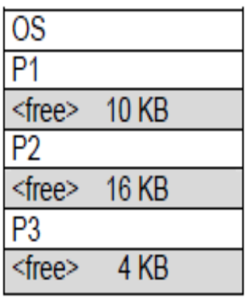 Before Allocation Using First, Best, Worst fit policy
if a new process, P5 of 14K arrives, then it would wait if we used worst fit

- Compaction
Compaction is a method to overcome the external fragmentation problem. To move all process one end & move all fragmented block at one end of memory; producing one large hole of available memory. If relocation is static and is done at assembly or load time, compaction cannot be done; compaction is possible only if relocation is dynamic and is done at execution time.
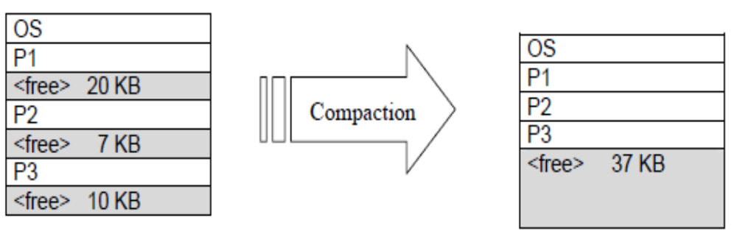
Another possible solution to the external fragmentation problem is to permit the logical address space of the processes to be non contiguous; thus allowing a process to be allocated physical memory wherever the latter is available. Two techniques achieve this solution – paging and segmentation.
- Paging
Contiguous allocation scheme requires that a process can be loaded into memory for execution if and only if contiguous memory large enough to hold the process is available. Paging allows a program to allocate noncontiguous blocks of memory. Paging avoids external fragmentation. Support for paging is handled by hardware.
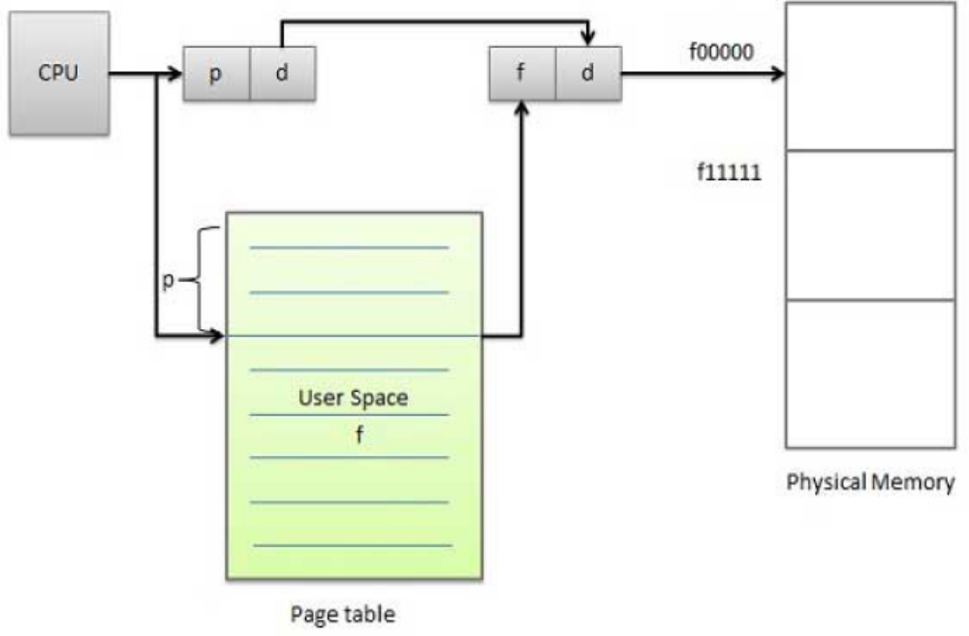
Figure: Paging hardware.
- Basic Method
Physical memory is divided into fixed sized blocks called frames.
Logical memory is divided into blocks of the same size called pages.
Allocation of main memory to processes for execution is then just mapping pages to frames. When a process is to be executed, its pages are loaded into any available memory frames from the backing store. This backing store is divided into fixed sized blocks that are of the same size as the memory frames.
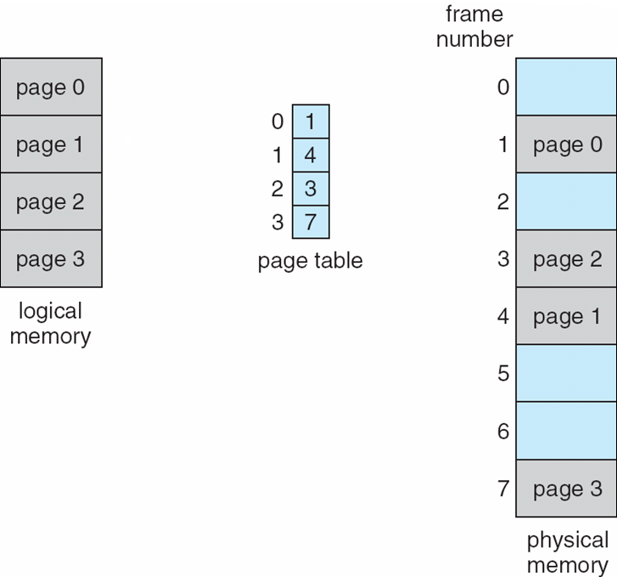

Figure: Paging model of logical and physical memory.
Every address generated by the CPU is divided into two parts: a page number (p) and a page offset (d). The page number is used as an index into a page table. The page table contains the base address of each page in physical memory. This base address is combined with the page offset to define the physical memory address that is sent to the memory unit.
The page size is defined by the hardware.
If the size of the logical address space is 2m, and the page size is 2n addressing units then the high order m-n bits of a logical address designate the page number and the n low order bits designate the page offset.
p
d
m - n
n
Page number
OS

P1 (80K)
20K empty
P2 (100K)

16K empty space
Page number
OS

P1 (80K)
20K empty
P2 (100K)

16K empty space

Logical address is given as above where p is an index into the page table and d is the displacement within the page. Example, consider the memory in next Figure. Here, in the logical address, n= 2 and m = 4. Using a page size of 4 bytes and a physical memory of 32 bytes (8 pages), we show how the user's view of memory can be mapped into physical memory. Logical address 0 is page 0, offset 0. Indexing into the page table, we find that page 0 is in frame 5. Thus, logical address 0 maps to physical address 20 [= (5 x 4) + 0]. Logical address 3 (page 0, offset 3) maps to physical address 23 [ = (5 x 4) + 3]. Logical address 4 is page 1, offset 0; according to the page table, page 1 is mapped to frame 6. Thus, logical address 4 maps to physical address 24 [ = ( 6 x 4) + O]. Logical address 13 maps to physical address 9.
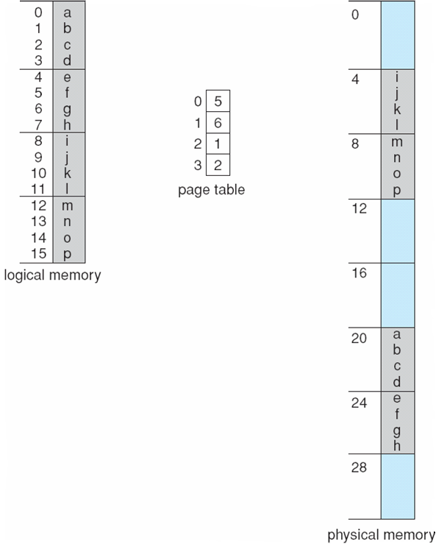
Paging itself is a form of dynamic relocation. Every logical address is bound by the paging hardware to some physical address. When paging scheme is used, there is no external fragmentation. Any free frame can be allocated to a process that needs it. But there might be some internal fragmentation. Frames are allocated as units. If the memory requirements of a process do not overlap with page boundaries, the last frame allocated may not be completely full.

Figure: Paging example for a 32-byte memory with 4-byte pages.
Since the OS manages physical memory, it must be aware of the allocation details of physical memory – which frames are allocated, which frames are available, how many total frames are
there etc. All this information is generally kept in a data structure called a frame table. The frame table has one entry for each physical page frame indicating whether the latter is free or allocated and if it is allocated to which page of which process or processes.
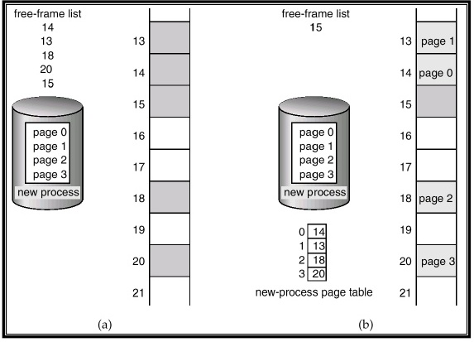
Figure: Free frames (a) before allocation and (b) after allocation.
- Hardware Support
Hardware implementation of a page table is done in a number of ways.
- In the simplest case the page table is implemented as a set of dedicated high-speed registers. But this implementation is suitable only if the page table is small.
- If page table size is very large. The page table is kept in main memory and a pointer called the page-table base register (PTBR) points to the page table.
- The disadvantage with this method is that it requires two memory accesses.
- For example, to access a CPU generated address, one memory access is required to index into the page table. Using access index value into PTBR it fetches the frame number when it combined with the page-offset produces the actual address.
- Using this actual address, the next memory access fetches inside of the preferred memory location.
- To overcome two access problems, Use hardware caches called translation look-aside buffers (TLBs). TLBs are associative registers that allow for a parallel search of a key item.
- The TLBs contain only a few or not entries. When a logical address generated by the CPU is to be mapped to a physical address, the page number is input to the TLBs. If the page number is found in the TLBs the corresponding frame number is available then a memory access can be complete.
- If the page number is not found in TLB then go to the page table fetch the corresponding frame number of a process. This page number is then added to the TLBs. The same address to next time when you will find a page number entry in the table. This hit will reduce one memory access and speed up address translation (Figure).
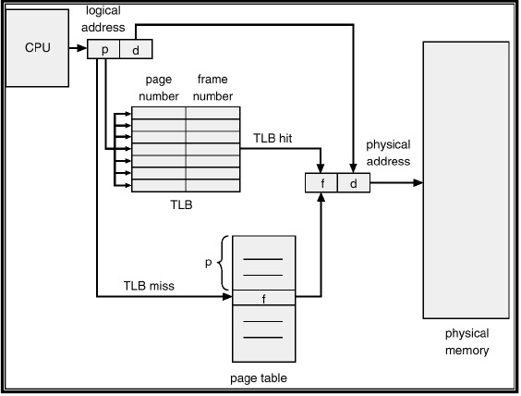
Figure : Paging hardware with TLB.
Every time a new page table is selected, the TLB must be flushed or erased to ensure that the next executing process does not use the wrong translation information. The percentage of times that a particular page number is found in the TLB is called the hit ratio.

- Protection
Each frame in physical memory is protected. Protection bits are used for this purpose. A page can have read only / execute only / read-write access. Hardware provides these protection accesses to frames. Illegal accesses are trapped by the operating system. Also a process needs to access frames corresponding to its pages only.
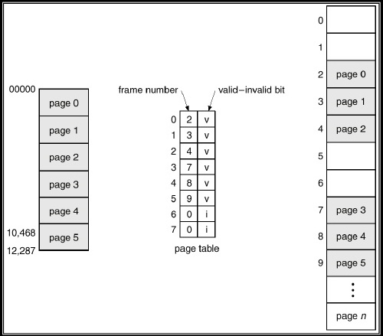
Figure: Valid (v) or invalid (i) bit in a page table.
A valid-invalid bit is thus associated with each entry in a page table. When the bit is set, the page belongs to the logical address space and thus has a corresponding frame. If the bit is not set, then the page is not in the process’ logical address space and hence access to the frame is denied (Figure).
One additional bit is generally attached to each entry in the page table – a valid – invalid bit. When the bit is set to valid, the page is associated in the process’s logical address space and this is a legal page. When the bit is set to invalid, the page is not in the process’s logical address space. OS trap this page and sets the invalid bit for that page. Disallow access of the page.

- Advantages of Page
- Paging reduces fragmentation.
- To increase degree of multiprogramming.
- Paging increase memory and CPU utilization.
- Compaction required operating cost for the relocatable partition scheme is also reduced.

- Disadvantages of Page
- Paging address mapping hardware increase the cost of computer.
- Some memory will be unused if number of available block is not sufficient for job to be run.

- Segmentation
Segmentation is a memory management scheme that supports the user view of memory. A logical address space divides into different smaller block is called as segment. Segmentation is variable sized & it dynamic partition because it have unequal size segment. The segment is a main program with a set of methods, procedures or functions. It may also include various data structures: objects, arrays, stacks, variables etc. Each segment has name and variable length which loaded into physical memory.
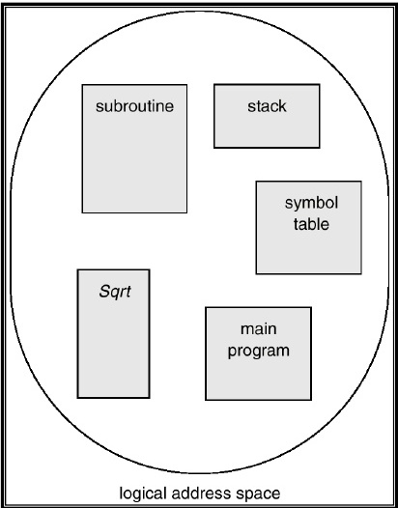
Figure A: Segmentation
The addresses specify both the segment name and the offset within the segment. The user specifies each address by two parts – < a segment name, an offset>. Segments are numbered instead of segment number. Thus a logical address consists of a two tuple: <segment – number, offset>. Segmentation reduces an internal fragmentation and suffers from external fragmentation. The user program is compiled and the compiler automatically constructs segments reflecting the input program. Libraries that are linked in during compile time might be assigned separate segments. The loader would take all these segments and assign them segment numbers.

- Hardware
The user can now refer to objects in the program by a two dimensional address, the actual physical memory is a one dimensional sequence of bytes. To define an implementation of mapping two dimensional users defined addresses into one dimensional physical address. This mapping is done by a segment table. Each entry in the segment table has a segment base and a segment limit.
- The segment base contains the starting physical address where the segment placed in memory.
- The segment limit specifies the length of the segment.
A logical address consists of two parts:
- A segment number s,
- An offset into that segment, d.
The segment number is used as an index to the segment table. The offset d of the logical address must be between 0 and the segment limit. If it is not then trap & returned. When an offset is legal, it is added to the segment base to produce the address in physical memory of the desired byte. The segment table is thus essentially an array of base – limit register pairs.
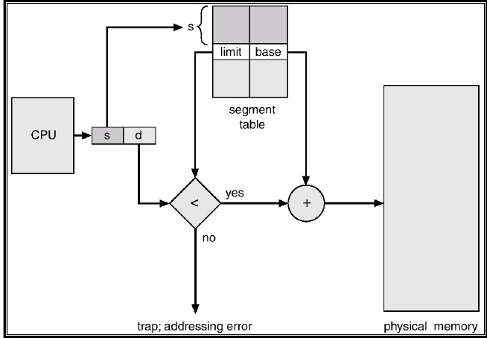
Figure A: Segmentation
As an example, shown in Figure (B). We have five segments numbered from 0 to 4. The segments are stored in physical memory as shown. The segment table has a separate entry for each segment, giving the beginning address of the segment in physical memory (or base) and the length of that segment (or limit). A segment 2 is 400 bytes long (limit) and begins at location 4300(base). Segment 2 is mapped on to location 4300 +400= 4700. A segment 3 1100 byte (limit) is mapped to 3200 (the base of segment 3) + 1100 = 4300.
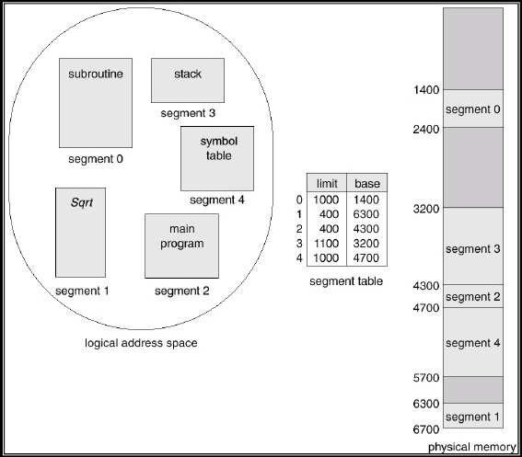
Figure B: Example of segmentation.

Questions:
Q-1) what is meant by fragmentation problem? How can it be controlled using Paging & Segmentation technique? Explain.
Q-2) Discuss in detail the segmentation scheme of memory management?
Q-3) Differentiate between:
(i) Swapping and Compaction
(ii) Logical address space and physical address space
Q-4) what is paging? How is it implemented?
Q-5) Describe the general objectives of the memory management system within an operating system.
Q-6) Why use Swapping? Explain it.
Q-7) Explain the memory allocation methods.
Q-8) Explain address Binding.

Virtual memory is a technique that allows the execution of process that cannot completely in main memory. Virtual memory is the separation of user logical memory from physical memory. The program size can be larger than available physical memory. Programmer burden of trying to fit program on limited memory. Virtual memory reduces external fragmentation. Speed up to execution of processes. The entire program is not required to load in main memory. Because of following situations,
1. User written error handling function are used only when an error occurs in the program
2. Some options and features of a program can be used rarely.
3. Many tables are assigned a fixed amount of address space but actually use only a small amount of address space.

The ability to execute a program that is only partially in memory would respond to many benefits.
1. Less number of I/O would be needed to load or swap each user program into memory.
2. A program would no longer be constrained by the amount of physical memory that is available.
3. Each user program could take less physical memory; more programs could be run the same time, with a corresponding increase in CPU utilization and throughput
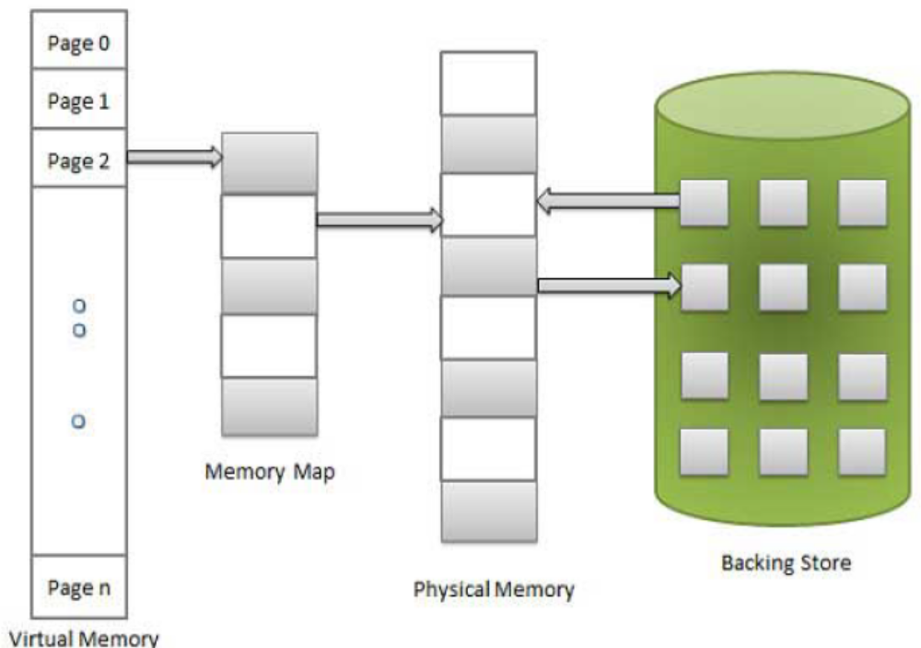
Fig: Diagram showing virtual memory that is larger than physical memory

Virtual memory is commonly implemented by Demand paging and Demand segmentation. Dynamic loading & overlays help to loading a program in memory.
- Demand Paging
A demand paging system is quite similar to a paging & swapping. Where processes reside in back store, when we want to execute a process, we swap it into memory. Swapping the entire process into memory, a lazy swapper never swaps a page into memory that page will be not needed.

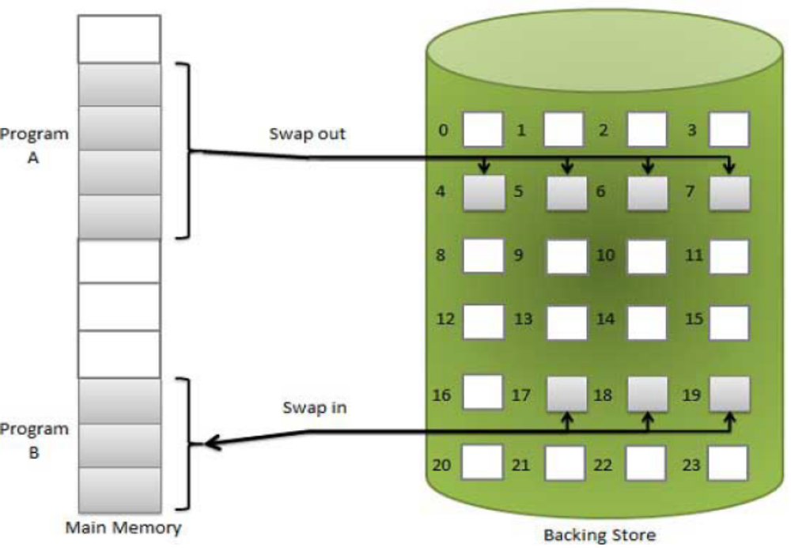
Figure: Transfer of a paged memory to contiguous disk space.

When a process is to be swapped in, then pager guesses which pages will be use before the process is swapped out again. Instead of swapping in a whole process, the pager brings only those pages into memory for its execution only when it required (demanded). In demand paging use pager rather than a lazy swapper. It avoids reading pages from main memory that is not used in anyway.
To decreasing the swap time and improve the physical memory. To load those pages into main memory only they are needed. This technique is known as Demand paging. With demand paged virtual memory, pages are only loaded when they are demanded during program execution.
Hardware support is required to differentiate between those pages that are in main memory and those pages that are on the back store (disk) using the valid-invalid bit scheme. When bit is set to “valid” the related page is legal and in main memory. If the bit is set to “invalid” the page is not in the logical address space of the process or but it valid because of page currently on the disk. In page-table entry for a page that is brought into memory is set as valid. Page-table entry for a page marked invalid that is not currently in memory or the page on disk.
While the process executes and accesses pages that are in memory then execution of process normally.
- Advantages
- Reduce memory requirement & More efficient use of memory.
- Reduce swap time.
- Increase degree of multiprogramming.
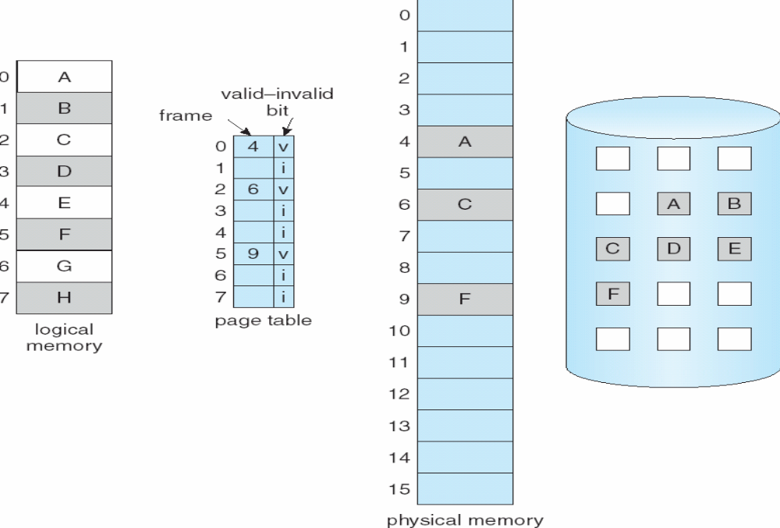
Fig: Page table when some pages are not in main memory
- Disadvantages
If program having 8 pages : 0,1,2,3,4,5,6,7 and out these only 3 pages are loaded 0,2,5 in memory at execution time. If program tries to access page 3 there will be error occur, because page is not present in main memory. It was not loaded at the time of swapping from disk to main memory. This error is called page fault.

- Page Fault:
If a process tries to access a page that was not present into memory. That is, to Access an invalid marked page causes a page fault occur. Operating system failure to bring the desired page into memory.
The page fault can be handled as following (Fig):
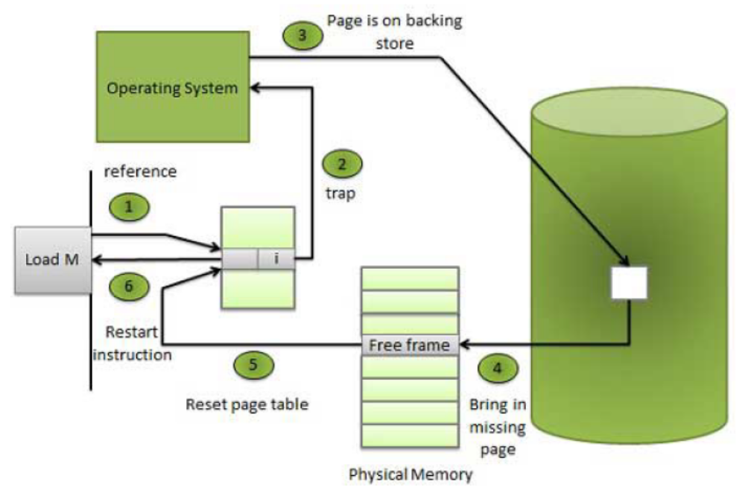
Fig.: Steps in handling a page fault
- We check an internal table for this process to determine whether the reference was a valid or invalid memory access.
- If the reference was invalid, we terminate the process. If it was valid, but we have not yet brought in that page, we now page in the disk.
- We find a free frame.
- We schedule a disk operation to read the desired page into the newly allocated frame.
- When the disk read is complete, we modify the internal table kept with the process and the page table to indicate that the page is now in memory.
- We restart the instruction that was interrupted by the illegal address trap. The process can now access the page as though it had always been memory.

We can start executing a process with no pages in memory. When pages are store on back store then page fault occur. Then that page is brought into memory, the process continues to execute. Faulting is compulsory when pages needed in memory. Process execute with no more faults this scheme is Pure Demand Paging: never bring a page into memory until it is required.
The hardware to support demand paging is the same as the hardware for paging and swapping:
- Page table: This table has the ability to mark an entry invalid through a valid -invalid bit or a special value of protection bits.
- Secondary memory: This memory holds those pages that are not present in main memory. The secondary memory is usually a high-speed disk. It is known as the swap device, and the section of disk used for this purpose is known as Swap-space.

- Page Replacement Algorithm
- We load several processes into memory at the same time. As we load only that pages are actually needed by each process at any given time.
- The memory is also needed for other purposes (such as I/O buffering).
- If some process suddenly decides it needs more pages and no any free frames available in memory?
- Then several possible solutions are:
- Adjust the memory used by I/O buffering. To free up some frames for user processes. The decision of how to allocate memory for I/O versus user processes is a complex one, use soft different policies on different systems.
- The process requesting more pages that time process put into a wait queue for when some free frames become available.
- Swap out some process from memory completely, free its page frames.
- Find some page in memory that is currently not used. Swap out unused page to disk and allocate that free frame to the requested process. This is known as page replacement. There are many different algorithms for page replacement.
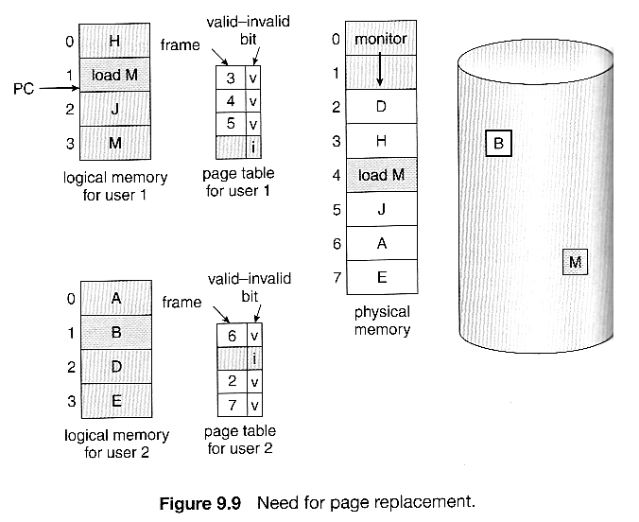

- Basic Page Replacement
The free frames are available on the free-frame list. Now the page-fault handling using page replacement:

- Find the location of desired page on the disk or in swap space.
- Find a free frame:
- If there is a free frame, use it.
- If there is no free frame, to find frame which is currently not used. This is called as victim frame.
- Write the contents of victim frame on disk. Change page tables entries that indicate that page is no longer in the main memory.
- Read the desired page into newly free frame; Change page and frame table’s entries.
- Restart the process.
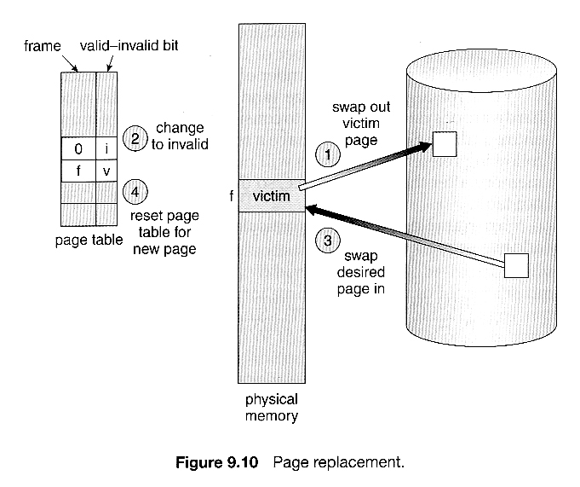
- FIFO Page Replacement
“Choose the oldest page as the victim frame for replace”. Which is load first in memory then swap out first and load new page into memory? Although FIFO is simple and easy; it is not even efficient. Replace pages from the tail and add new pages at the head. FIFO is Belady's anomaly is increasing the number of frames available can actually increase the number of page faults that occur.
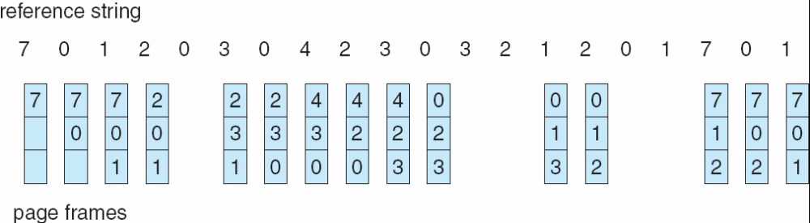
In FIFO, 20 page requests and 15 page faults occurs.

- Optimal Page Replacement
In this algorithm “Replace that page will be used in the future after longest time" OR “Replace the page that will not be used for the longest period of time”. OPT has the lowest page fault rate between all of the page replacement algorithms, but there is problem of this algorithm.OPT is not possible to be implemented because it requires future knowledge. It is used for performance comparison. The lowest possible page-faults, and which does not suffer from Belady’s anomaly?
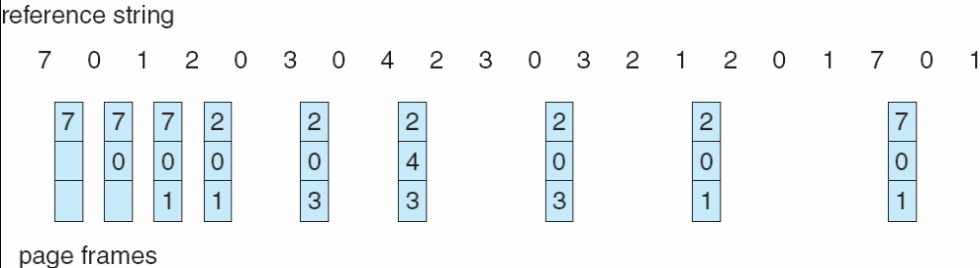
09 page faults occur.

- LRU (Least Recently Used) Page Replacement
“Replace that page has been not used from longest time”. LRU is considered a good replacement policy, and is often used. LRU perform better than FIFO.
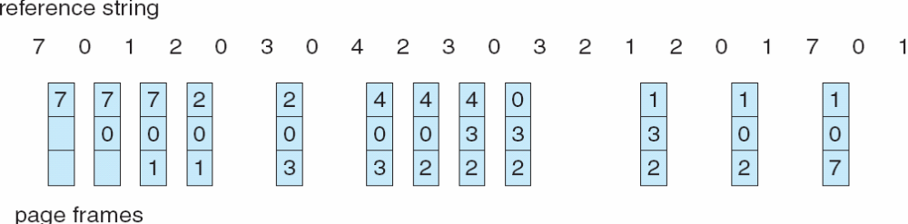
12 page faults occur
Examples
- Assume we have 3 frames and consider the reference string below.
Reference string: 5, 7, 6, 0, 7, 1, 7, 2, 0, 1, 7, 1, 0
How many page fault occur by using following algorithm
- First-In-First-Out (FIFO)
- OPT
- Least Recently Used (LRU)
- Assume we have 3 frames and consider the reference string below.
Reference string: 1,2,3,4,2,1,5,6,2,1,2,3,7,6,3,2,1,2,3,6
How many page fault occur by using following algorithm
- First-In-First-Out (FIFO)
- OPT
- Least Recently Used (LRU)

Questions
1. What is logical address space and physical address space?
2. What is the main function of the memory-management unit?
3. Define dynamic loading and dynamic linking.
4. What are overlays?
5. Define swapping.
6. What are the common strategies to select a free hole from a set of available holes?
7. What do you mean by best fit and first fit?
8. What is virtual memory?
9. What is Demand paging?
10. Define secondary memory.
11. What is the basic approach of page replacement?
12. What is the various page replacement algorithms used for page replacement?
13. What are the major problems to implement demand paging?
14. What is a reference string?
15. Define virtual memory

16. Explain about contiguous memory allocation.
17. Give the basic concepts about paging.
18. Write about the techniques for structuring the page table.
19. Explain the basic concepts of segmentation.
20. What is demand paging and what is its use?
21. Explain the various page replacement strategies.
22. What is meant by virtual memory? Give some major benefits which are making applicable.
23. Consider the following page reference string.
1,2,7,8,3,4,2,1,4,2,5,6.How many page fault would occur for the following page replacements algorithms, assuming an allocation of 3 frames?
(i)LRU (ii) FIFO (iii) Optimal
b) Given memory partitions of 100k,500k,200k,300k and 600k(in order)how would each of the first fit, best fit and worst fit algorithm please process of 412k,317k,112k and 326k(in order)?

